**1104 Mar 2021: Tutorial 6**

Q1) Lay 6.1/pg 336/Q1

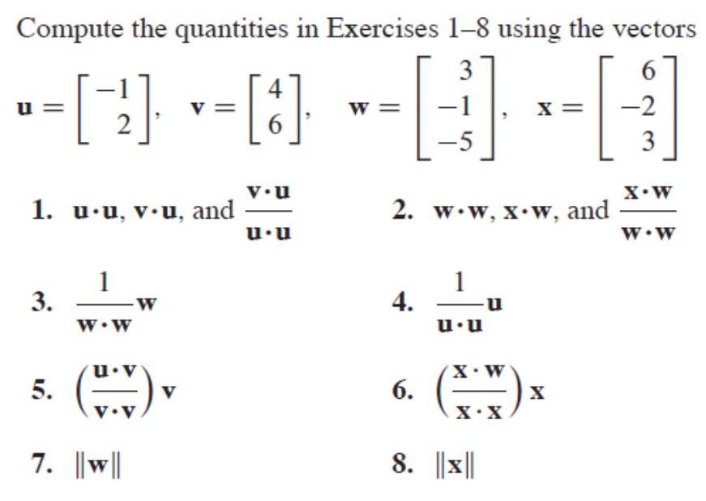

Ans Q1:

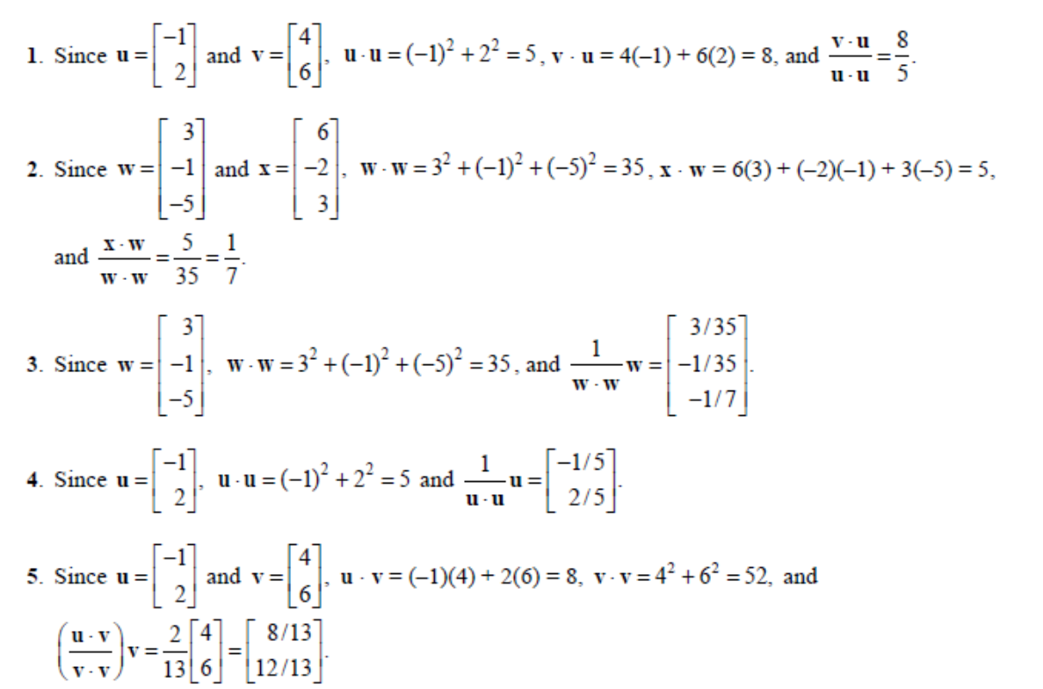

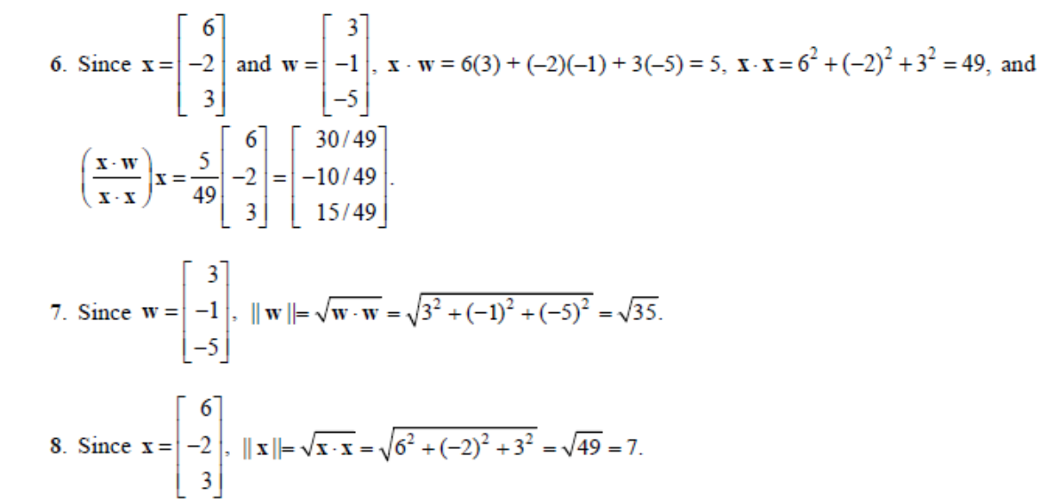

Q2) Lay/ pg 337/ Q19

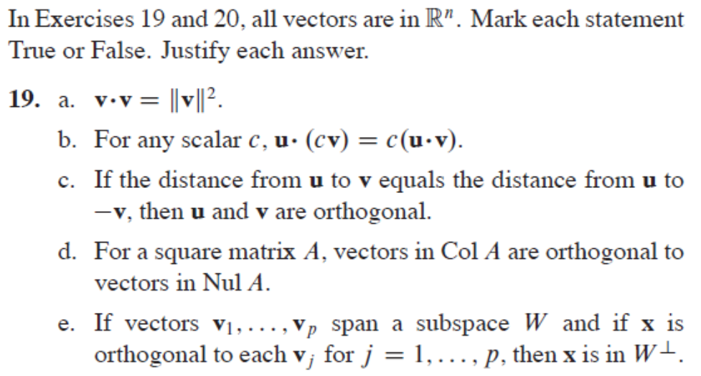

Ans:

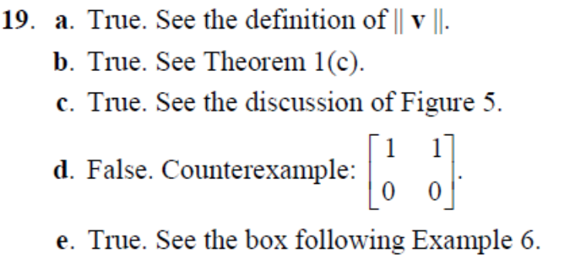

Q3) Lay Q30)

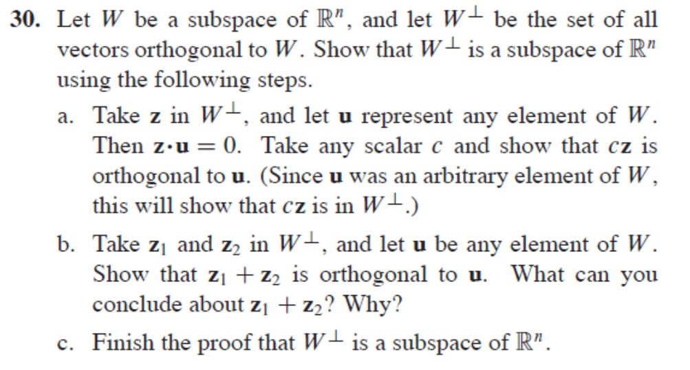

Ans:

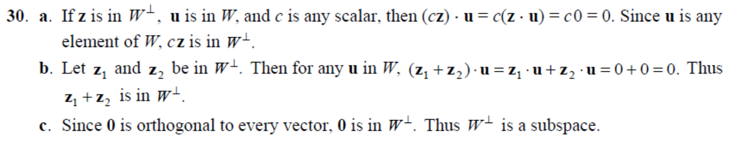

Maths/LA/Tut6.2/Orthogonal Sets

Q4) Lay Example 3, pg 340

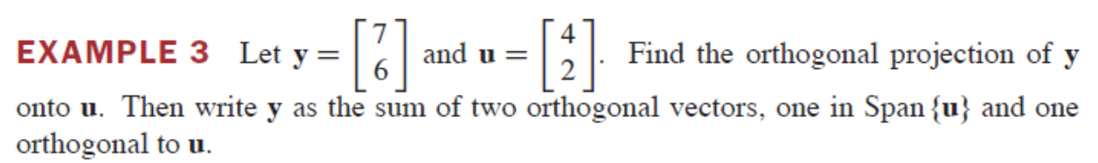

Ans:

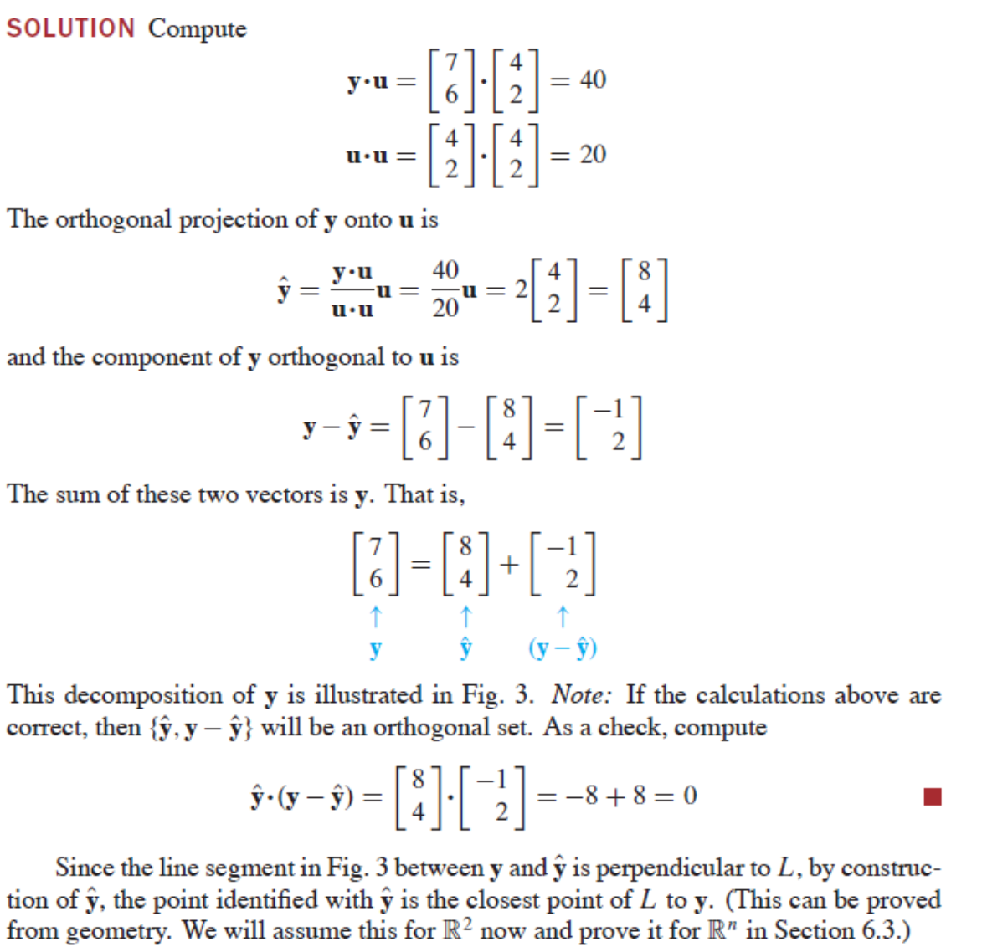

Q5) Lay/pg 345/Q17

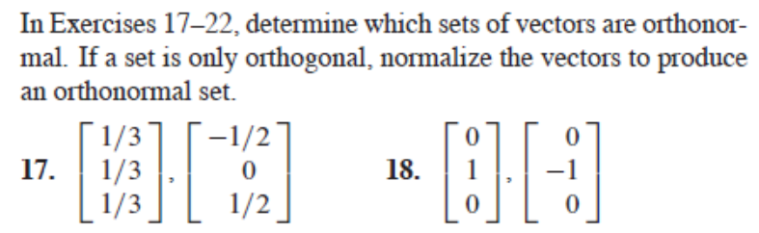

Ans:

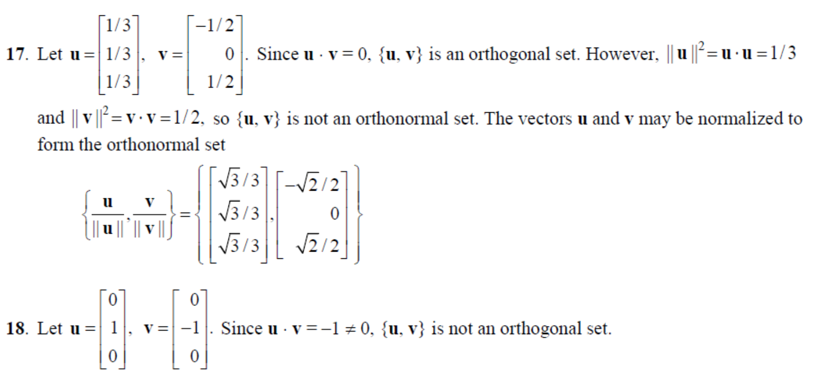

Q6) Lay/pg 345/Q23+24

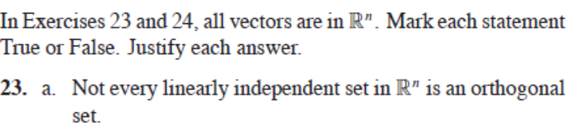

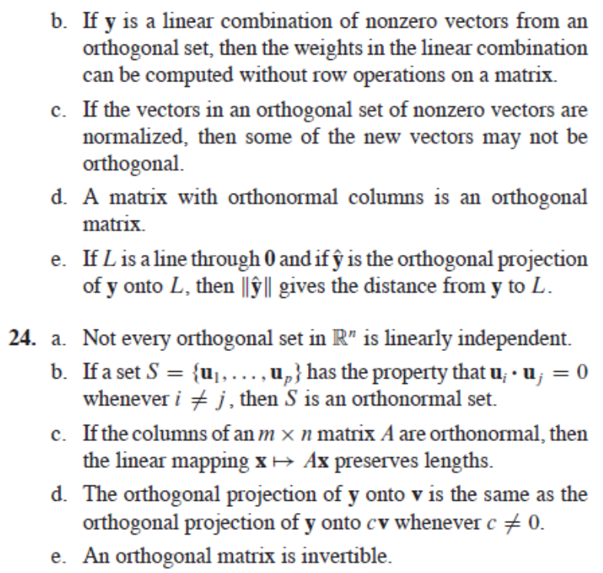

Ans:

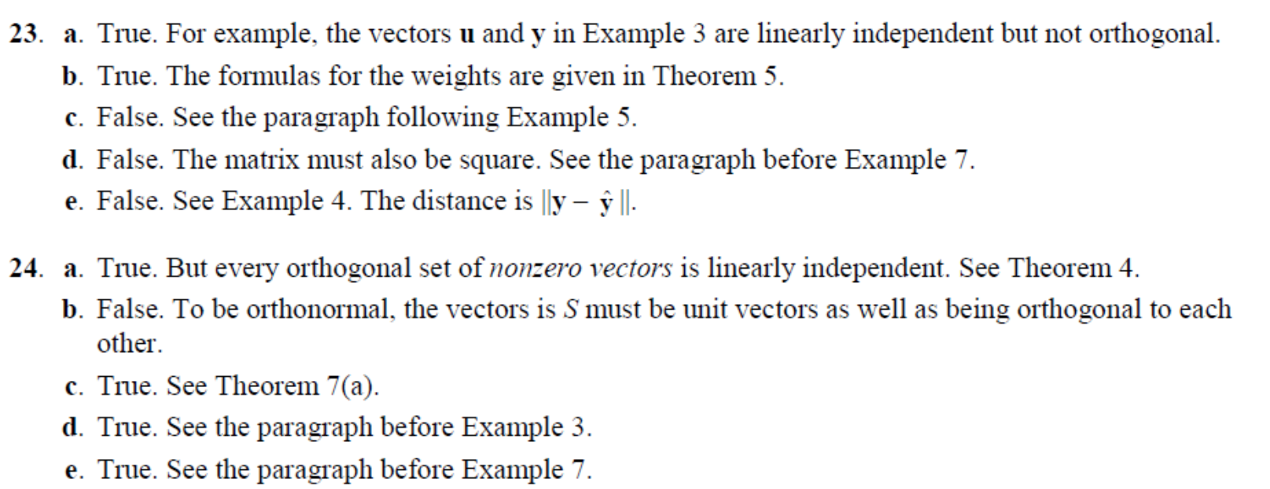

Q7) Lay/pg 345/Q31

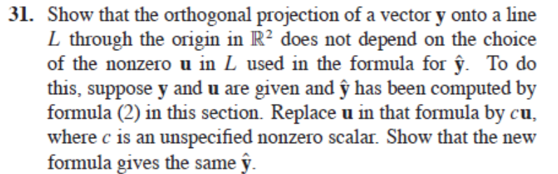

Ans:

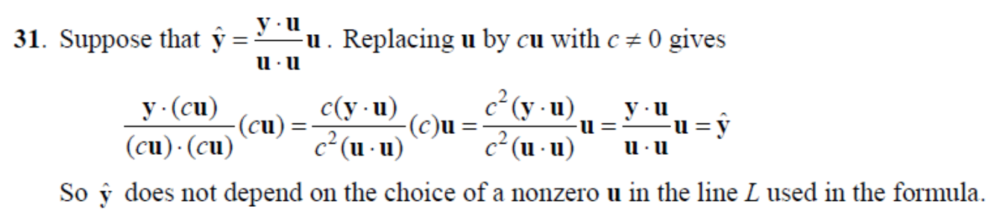

Tut6.3/OrthogonalProjection and GramSchimdt/

Q8) Lay/pg351/Example3/Example4

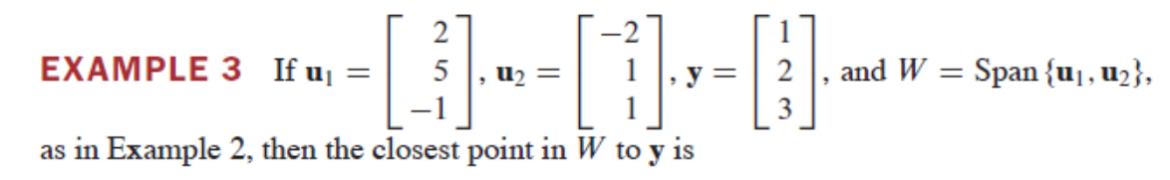

Ans: 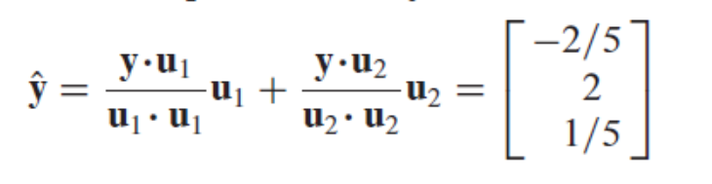

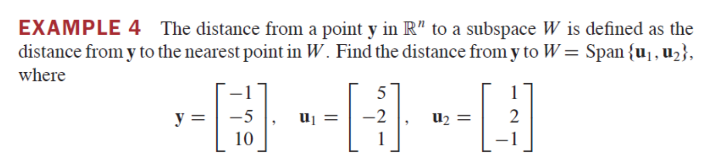

Ans:

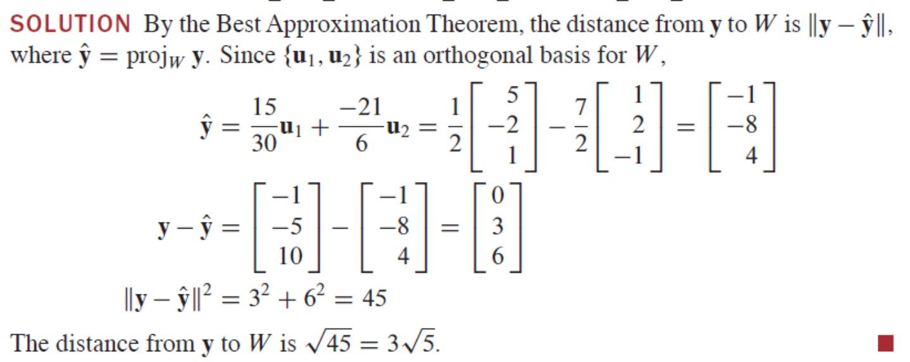

Q9) Lay/pg353/Q21+22

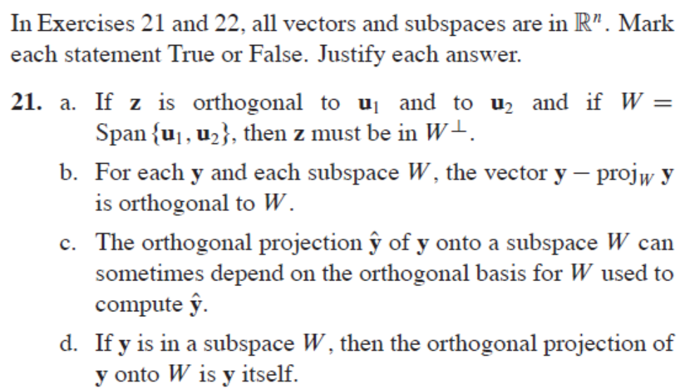

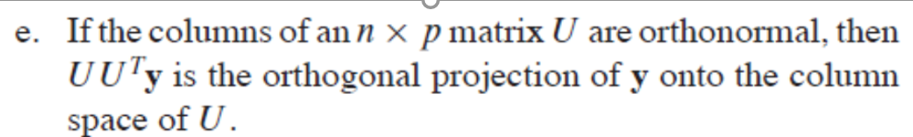

Ans:

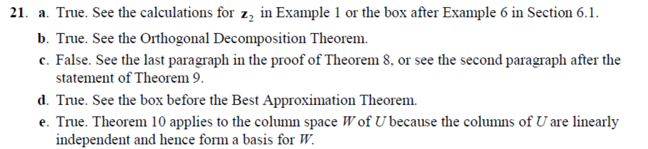

Q10) Lay/pg 359/Q19+20

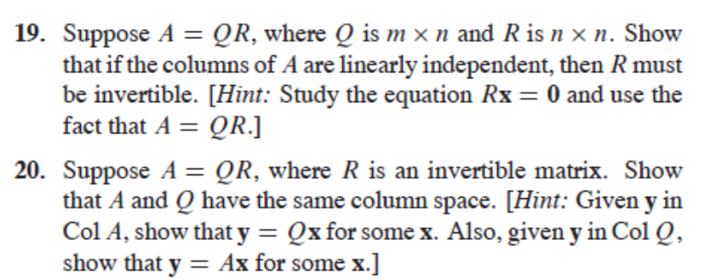

Ans:

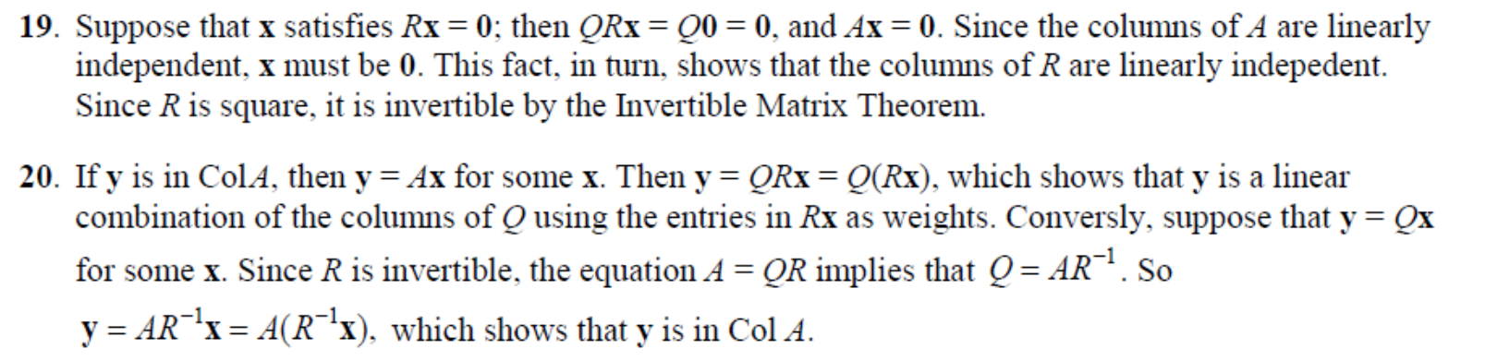

For 19, can also use dim col(A) = n, since col A are independent. Hence dim (ker) = 0 by rank theorem, implying x = 0. Hence R is invertible…